Batch: C1 Roll No.: 16010122221
Experiment No. : 09
Grade: AA / AB / BB / BC / CC / CD /DD

Signature of the Staff In-charge with date

Title: Implementation of de-fuzzification methods (Center of Sum, Centre of
Gravity, Mean of Maximum).
____________________________________________________________________________________
Objective: To understand de-fuzzification methods
____________________________________________________________________________________
Expected Outcome of Experiment:

CO4 : Apply basics of Fuzzy logic and neural networks ____________________________________________________________________________________
Books/ Journals/ Websites referred:

____________________________________________________________________________________
Pre Lab/ Prior Concepts:
____________________________________________________________________________________

Defuzzification :
Defuzzification is the process of producing a quantifiable result in Crisp logic, given fuzzy sets and corresponding membership degrees. It is the process that maps a fuzzy set to a crisp set. It is typically needed in fuzzy control systems. These will have a number of rules that transform a number of variables into a fuzzy result, that is, the result is described in terms of membership in fuzzy sets. Defuzzification is the conversion of a fuzzy quantity to a precise quantity, just as fuzzification is the conversion of a precise quantity to a fuzzy quantity. µ
For example, Fig (a) shows the first part of the Fuzzy output and Fig (b) shows the second part of the Fuzzy output.
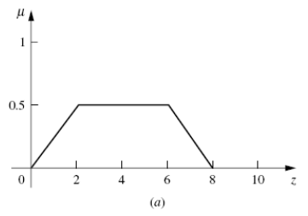
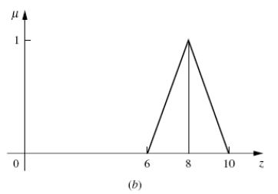
Then Fig (c) shows the union of the two parts (a) and (b).
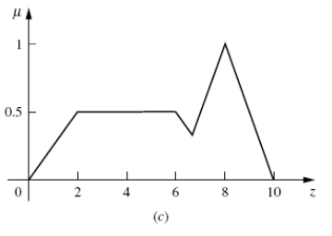

Different Defuzzification methods
- Max membership method

This method is also known as height method and is limited to peak output functions. This method is given by the algebraic expression:
µ(z*) >= µ(z) for all z ∊ Z.

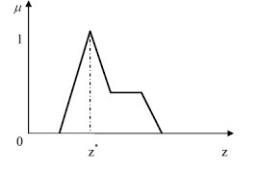
- Center of gravity or centroid
This method is also known as the centre of mass, centre of area or centre of gravity. It is the most commonly used defuzzification method. The defuzzified output z* is given by:
z* = ∫µ(z).zdz / ∫µ(z)dz

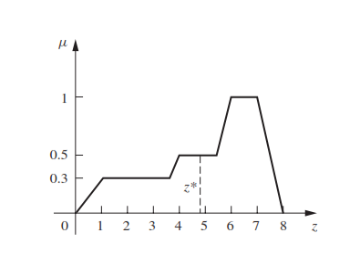

- Centre of sums

This method employs the algebraic sum of the individual fuzzy subsets instead of their union. The calculations here are very fast, but the main drawback is that the intersecting areas are added twice. The defuzzified value z* is given by
z* = ∫ z*∑µ(z).zdz / ∫ ∑µ(z)dz
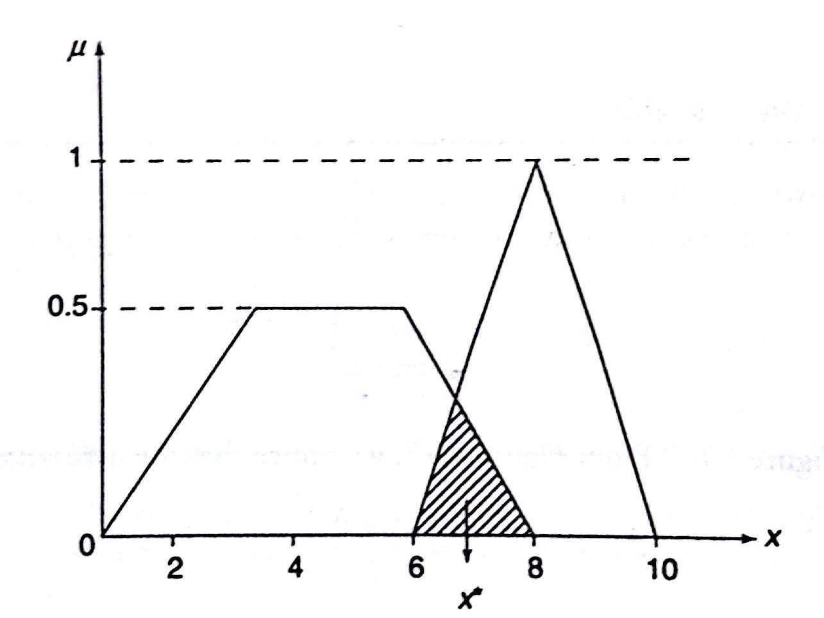

- Mean of maximum method
This method is also known as the middle of the maxima. This is closely related to the max-membership method, except that the locations of the maximum membership can be nonunique. The output here is given by:
z* = ∑z' / n ; where z' is the maximum value of the membership function.
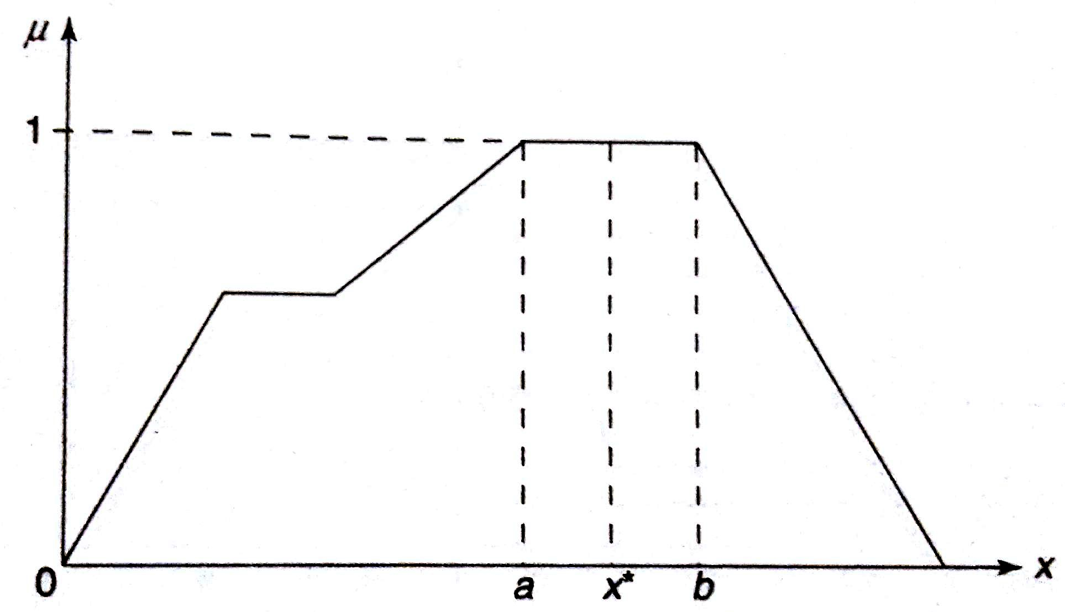

____________________________________________________________________________________
- Weighted average method
This method is valid for symmetrical output membership functions only. Each membership function is weighted by its maximum membership value. The output in the case is given by
z* = ∑µ(z').z' / ∑µ(z') ; where z' is the maximum value of the membership function.

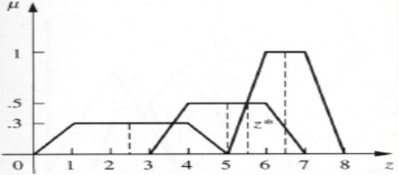

- Centre of Largest Area
This method can be adopted when the output of at least two convex fuzzy subsets which are not overlapping. The output, in this case, is biased towards a side of one membership function. When output fuzzy st has at least two convex regions, then the centre of gravity of the convex fuzzy subregion having the largest are is used to obtain the defuzzified value z*. The value is given by

z* = ∫ µc(z).zdz / ∫ ∑µc(z)dz

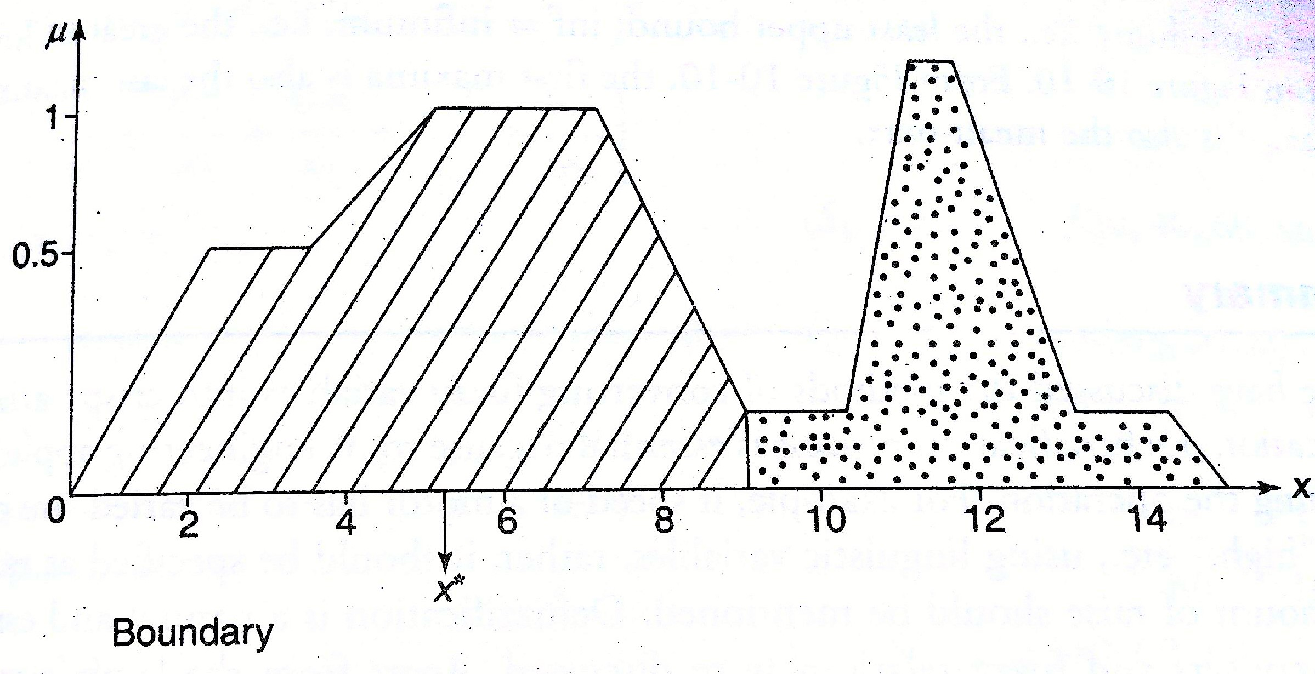

Implementation Details:

Implement the above 6 defuzzification methods (draw graph)

Code and Snap shot of graph

import matplotlib.pyplot as plt

def plot_membership_function(data):
plt.plot(data, label='Membership Function')
plt.xlabel('Index')
plt.ylabel('Membership Value')
plt.legend()
plt.show()

def lambda_cut_method(data):
lambda_value = float(input("Enter lambda value: "))
cut_data = [x for x in data if x >= lambda_value]
print("Lambda Cut Method Result:", cut_data)
plot_membership_function(data)

def weighted_average(data):
weights = [float(w) for w in input("Enter weights corresponding to each defuzzy value: ").split()]
if len(weights) != len(data):
print("Error: Number of weights should match the number of data points.")
return
weighted_avg = sum([data[i] * weights[i] for i in range(len(data))]) / sum(weights)
print("Weighted Average:", weighted_avg)

# Plot weighted average
plt.axhline(y=weighted_avg, color='r', linestyle='--', label='Weighted Average')
plot_membership_function(data)
def height_of_maxima(data):
max_value = max(data)
print("Height of Maxima:", max_value)

# Plot maxima
max_indexes = [i for i, value in enumerate(data) if value == max_value]
plt.scatter(max_indexes, [max_value] * len(max_indexes), color='r', label='Maxima')
plot_membership_function(data)

def first_of_maxima(data):
max_value = max(data)
first_index = data.index(max_value)
print("First of Maxima:", data[first_index])

# Plot first maxima
plt.scatter(first_index, max_value, color='r', label='First of Maxima')
plot_membership_function(data)

def last_of_maxima(data):
max_value = max(data)
max_indexes = [i for i, value in enumerate(data) if value == max_value]
last_index = max_indexes[-1]
print("Last of Maxima:", data[last_index])

# Plot last maxima
plt.scatter(last_index, max_value, color='r', label='Last of Maxima')
plot_membership_function(data)
def mean_of_maxima(data):
max_value = max(data)
max_indexes = [i for i, value in enumerate(data) if value == max_value]
mean_maxima = sum([data[i] for i in max_indexes]) / len(max_indexes)
print("Mean of Maxima:", mean_maxima)

# Plot mean maxima
plt.axhline(y=mean_maxima, color='r', linestyle='--', label='Mean of Maxima')
plot_membership_function(data)

def centre_of_centroid(data):
centroid = sum(data) / len(data)
print("Centre of Centroid:", centroid)

# Plot centroid
plt.axhline(y=centroid, color='r', linestyle='--', label='Centre of Centroid')
plot_membership_function(data)
def centre_of_sum(data):
total_sum = sum(data)
sum_data = [data[i] / total_sum for i in range(len(data))]
weighted_sum = sum([(i + 1) * sum_data[i] for i in range(len(data))])
print("Centre of Sum:", weighted_sum)

# Plot centre of sum
plt.axvline(x=weighted_sum, color='r', linestyle='--', label='Centre of Sum')
plot_membership_function(data)
def get_data_input():
while True:
try:
data = [float(x) for x in input("Enter defuzzy values (space-separated numbers): ").split()]
if len(data) == 0:
raise ValueError("Input cannot be empty.")
return data
except ValueError:
print("Invalid input. Please enter valid numerical values.")

# Main program
data = get_data_input()
while True:
print("\nMenu:")
print("1. Lambda Cut Method")
print("2. Weighted Average")
print("3. Height of Maxima")
print("4. First of Maxima")
print("5. Last of Maxima")
print("6. Mean of Maxima")
print("7. Centre of Centroid")
print("8. Centre of Sum")
print("9. Exit")
choice = input("Enter your choice: ")

if choice == '1':
lambda_cut_method(data)
elif choice == '2':
weighted_average(data)
elif choice == '3':
height_of_maxima(data)
elif choice == '4':
first_of_maxima(data)
elif choice == '5':
last_of_maxima(data)
elif choice == '6':
mean_of_maxima(data)
elif choice == '7':
centre_of_centroid(data)
elif choice == '8':
centre_of_sum(data)
elif choice == '9':
break
else:
print("Invalid choice. Please enter a valid option.")
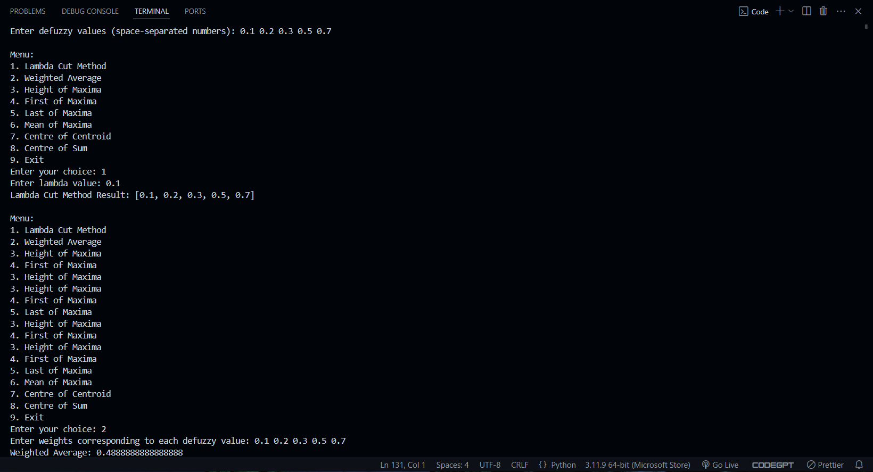

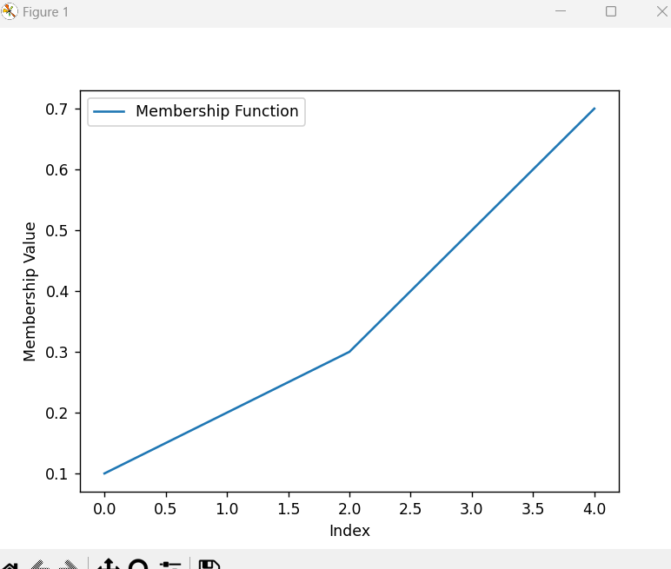

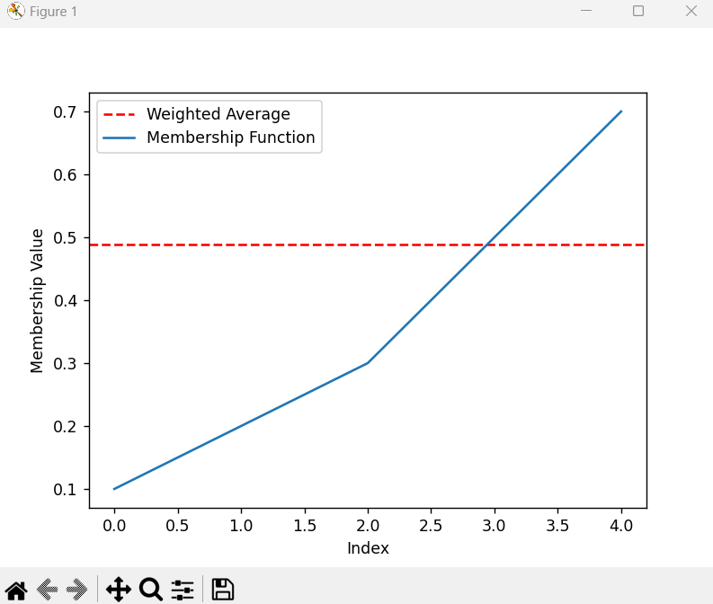

Conclusion: Implementation of defuzzification methods was done successfully.

Post Lab Descriptive Questions :
Find crisp value corresponding to the following fuzzy output sets using various de-fuzzification methods.
